WALKERVILLE ALL CARS CLUB
WALKY PARK SERIES

Round 3
22nd/23rd of July 2023

Further Regulations 1

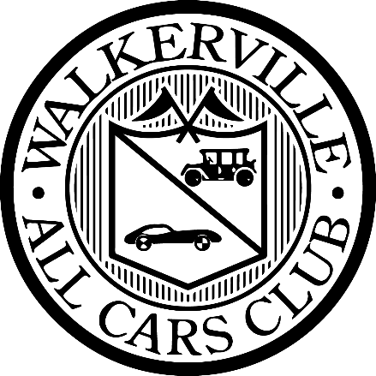

Black Nitro SA - SA Khanacross Championship & Walky Park Series Round 3

The Walkerville All Cars Club would like to extend a sincere thank you to our valued sponsor for this round, Black Nitro SA by ikklefellas.
Distributed in South Australia exclusively by IKKELFELLAS, Black Nitro Coffee is the perfect companion for those seeking a bold and energizing experience. This revolutionary cold brew is infused with nitrogen, resulting in a silky smooth texture and a rich, velvety taste that will tantalize your taste buds like never before. With its intense flavor and invigorating caffeine kick, Black Nitro Coffee is the ultimate choice for coffee connoisseurs and adrenaline enthusiasts alike.

As the proud sponsor for round 3 of the 2023 Walky Park Khanacross Series, IKKLEFELLAS is bringing the excitement of Black Nitro Coffee to the heart of South Australia's motorsport scene. What better way to fuel the drivers, crew, and spectators than with the electrifying boost of Black Nitro Coffee?

Whether you're behind the wheel or cheering from the sidelines, join us as we kick-start the racing season with the unmatched flavor and energy of Black Nitro Coffee, brought to you by IKKELFELLAS in South Australia.



Black Nitro SA by ikklefellas
22 Acrylon Road. SALISBURY SOUTH SA 5106
Call on : 1300 886477
blacknitrosa.com.au

1 . Updated - Officials of the Day

1.1 – Clerk of Course (Saturday) – Tamara Brice
1.2 – Clerk of Course (Sunday) – Ellie Brice
1.3 – Deputy Clerks of Course – Iz Singe (Both Days), Ellie Brice (Saturday), Tamara Brice (Sunday)
1.4 – Chief Scrutineer – Bob Nason
1.6 – Chief Timekeeper – Ellie Brice
1.7 – Secretary – Steve Barker
1.8 – Safety Officer – Greta Nason
1.9 – Media Coordinator – Ellie Brice

2 . Updated - Championship Regulations

2.1 – It has been brought to our attention that the SA Khanacross Championship Regulations – As linked on the Motorsport Australia Event Portal are an outdated set of regulations.
2.2 – For the current and updated version of the regulations please visit either:
- The Walkerville All Cars Club Website - wacc.asn.au/motorsport
- The Event online Notice board in the Sportity APP
2.3 – The Current SA Khanacross Championship points will also available at both locations above as of Tuesday 18/07/2023

3 . Reminder - Sportity

3.1 – All event documentation and forms will be available on the event virtual notice board - Sportity APP and website, this will be the primary source of information pre-event, post-event and throughout and will be used at all events this season.

3.2 – Pre-event you can also access sportity directly from your web browser by following the link below this allows for the easy download of pre-event forms and paperwork

3.3 – LINK TO SPORTITY RALLYSPINT WEBSITE
